If I get upset, DO…
Reassure me
Use positive words.
Help me change my focus to something I like.
Use active listening, let me vent safely, and help me move on when I am ready.
Help me problem solve by letting me know what my options are.
Communicate clearly and honestly.

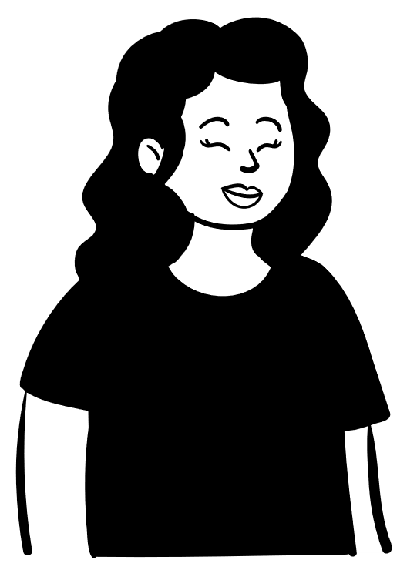
I Enjoy….
Watching Disney Films
Reading books with another person
Going to MacDonalds
Having a good chat
Ice Cream
Water therapy
Being Independent

I don't like…
Hospitals and Ambulances, Certain noises
Arguing
Waiting
Cars in the way
School children shouting or being in the way.

If I get upset DON'T…
Focus on the thing that is upsetting.
Discuss things in front of me that aren't relevant.
After I am Calm…
Praise me for my successes in dealing with things that make me anxious or upset.
I like overcoming problems and feeling proud of myself. Celebrate with me!
Show off to everyone the things that I did that worked well.
Make plans with me about how to approach problems in the future.

Talk to me about…
Nurse Becky from 'The Royal'
Nurses in general
Anything Disney but particularly:
- Beauty and the beast
- Lilo and Stitch
- Cinderella
- Disney princesses
'Home and Away girl'
The Worst Witch, Mildred
Father Ted: Dougal, Father Jack
Emmerdale, Lisa Dingle, Zac, Belle
Fun House, Pat Sharpe, "Funny Haircut"
High School Musical the Bill
Tracy Beaker Neighbours
Casualty, (Charly) On the Buses Comfort, Flash, L'Oréal Brookside

Aim: To promote consistent approaches and reduce instances of behaviour that challenges. This is a condensed version of a full Positive Behaviour Support Plan for use when a supporting staff member requires fast access to information that will help them maintain a person's wellbeing and quality of life.
Presenting behaviour  How the person appears when calm and relaxed | Support strategies  What we can do to maintain baseline.
Chatty, giggly, sociable, helpful.  Enjoys and feels motivated to do things independently. Enjoys overcoming challenges.  Happy to engage with supporting staff.  Uses happy tones and positive language e.g., "xxxx’s happy/excited" "got the giggles" | Encourage independence and celebrate achievements with xxxx.  Use a confident and positive attitude.  Involve xxxx in her support to enable her to feel in control.  Make achievable plans with xxxx.
Primary prevention:

Triggers | Presenting behaviour: when becoming anxious/agitated | Support Strategies: Things that prevent escalation
Ambulances.  Noise/noise from peers. Favourite Objects being lost or broken, Waiting/transitions.  Change in Routine.  Unfamiliar things or unknowns/being misunderstood.  "Arguments". | Tense tone of voice, higher in volume.  Hands to ears/head.  Saying "No" or  "I want to go back to bed." | Lots of reassurance.  Take a pause and use active listening.  Support xxxx to "solve the problem".  Use xxxx’s own self soothing language and familiar topics to redirect or as a coping tool. (See 1st page)  Prepare xxxx for potential triggers in near future. Build xxxx’s confidence so she can overcome challenges.
Early indicators/Secondary prevention:

Presenting behaviour: How the person appears when agitated | Support strategies: Things that prevent further escalation and keep people safe
Shouting/screaming/stamping feet  Get upset and cry  Hitting out  Refusal to move  Throw self back in chair or wheelchair forcefully | Remind xxxx of her self-soothing strategies:  Taking a deep breath, saying "quiet voice ____"  Step back or leave the room to allow her to vent and self soothe. Offer lots of reassurance, use soft tones, use positive and caring language.
Reactive strategies:

Presenting behaviour: | Support strategies
xxxx may want to try and make sense of what has happened, asking why, and commenting on it.  Usually willing to move on with prompts. | Use active listening and lots of reassurance.  Use an upbeat positive manner.  Suggest moving on and redirect to positive things/thoughts/activities/things xxxx’s likes.
Post incident:

